Cultural ontology of Pakistan

(Project Proposal)

Project Code
___________________

Project Advisor
Waleed Ahmad
Project Manager
Respected Sir Fahad Maqbool
Project Team
Wajid Ali (R049)
Shoaib Khalid (R030)
Nafia Ramzan (R011)
Submission Date
04 OCT 2023
Table of Contents
1. Abstract 3
2. Background and Justification 3
3. Project Methodology 3
4. Project Scope 3
5. High level Project Plan 3
6. References 3

Abstract

Pakistan is a land of diverse cultures. But people do not know enough about different cultures of Pakistan. One of the major challenge in learning about the cultures is not enough organized information about the cultures is readily available.Developing a cultural ontology is challenging, as it involves defining key concepts and creating a structured, machine-readable representation. Our approach involves thorough research to identify these concepts and their connections. Ontology is now a popular way to represent formal, machine-readable knowledge. Our project aims to fill the gap by creating a comprehensive, structured representation of Pakistan's diverse culture. Researchers and students can use ontology to find patterns in cultural data, develop new theories about Pakistani culture, and gain knowledge. It can create interactive learning modules and mobile apps for tourists. Ontology helps build databases of Pakistani cultural products and enhances cross-cultural communication through tailored translation tools.

Background and Justification
Cultural ontology is a relatively new field that seeks to develop formal representations of cultural knowledge. Cultural ontology can be used to support a variety of applications, such as preserving cultural heritage, promoting cultural understanding, and developing new cultural products and services.
There has been no prior work done on the ontology of Pakistan.The ontology covers a wide range of topics, including Pakistani culture food, costumes ,traditions and languages.
There are a number of reasons to work on cultural ontology in Pakistan. First, it would help to preserve and promote Pakistani culture. Second, it would support cultural development and innovation. Third, it would facilitate cross-cultural communication and understanding.
It would also help to promote Pakistani culture and values both domestically and internationally.

Project Methodology
To achieve the objectives of the project, an NEON methodology will be adopted .The NEON methodology is a comprehensive and well-established methodology for ontology development. The project will be divided into several key action steps:

1. Collect Diverse Cultural Artifacts: we will gather items like literature, art, oral traditions, and historical records from all over Pakistan. Partner with cultural experts and communities for a thorough collection.

2. Design Conceptual Ontology:
We will use advanced techniques to define key cultural concepts and relationships, ensuring they fit NEON's framework.

NEON will be included following phases:

- Phase 1: Need Analysis

This phase will involve conducting a needs assessment to identify the specific needs of the target users. The needs assessment will be conducted through interviews and focus groups with experts in the field of Pakistani culture, as well as with potential users of the ontology.
- Phase 2: Existing Ontologies
This phase will involve researching existing ontologies. The research will focus on identifying ontologies that are relevant to the scope of the our pakistan culture ontology, and that are compatible with existing ontologies.

- Phase 3: Ontology Requirements
Based on the needs analysis and the research on existing ontologies, the requirements for the our ontology will be defined. The requirements will specify the scope of the ontology, the level of granularity, and the types of entities and relationships that will be included.

- Phase 4: Ontology Development
The ontology will be developed using a variety of tools and methods. The development process will be iterative, with the ontology being refined and extended as more knowledge is acquired.
- Phase 5: Ontology Evaluation
The ontology will be evaluated by a group of experts in the domain of Pakistani culture. The evaluation will focus on assessing the accuracy, completeness, and usefulness of the ontology.
- Phase 6: Ontology Deployment
The ontology will be deployed in a variety of ways, such as publishing it online or integrating it into a software application.
- Phase 7: Ontology Maintenance
The ontology will be maintained and updated on a regular basis to ensure that it remains accurate and up-to-date.

3. Create Categories:
We will develop a system that groups cultural elements based on common characteristics for easy organization and navigation.

4. Add Meaningful Details: we will attach labels to artifacts, connecting them to relevant concepts in the ontology and we will use language tools to enhance the content.

5. Connect Related Ideas: we will establish links between connected concepts, enabling exploration of cultural ties and dependencies.

6. Check for Accuracy and Usefulness:
We will Involve experts and practitioners to confirm the ontology's correctness, coherence, and completeness and conduct studies to see how effective it is for cultural research and preservation.

Project Scope
There are some functionalities that our Pakistan culture ontology project could provide
It can identify and define the key concepts and relationships that make up Pakistani culture,Create a structured and machine-readable representation of this knowledge,Make the ontology accessible to a wide range of users,Promote the use of the ontology in research, education, and cultural development initiatives.However, there are some functionalities that a cultural ontology of Pakistan should not provide:it cannot Translate languages,can’t Generate creative text formats of text content, like poems, code, scripts, musical pieces, email, letters, etc,can’t Answer your questions in an informative way, even if they are open ended, challenging, or strange.

High level Project Plan

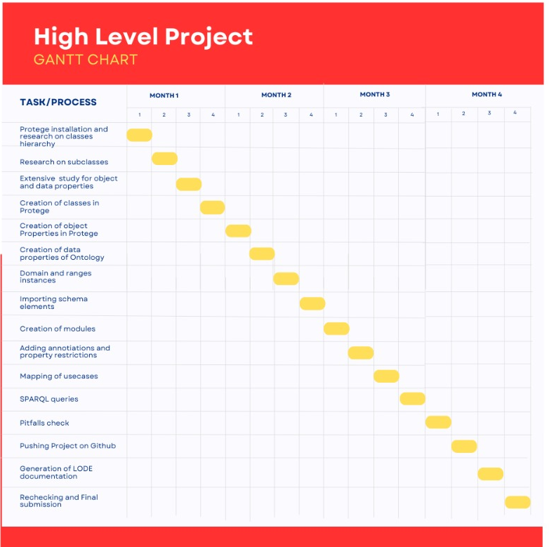

References
- Doerr, M. (2009). Ontologies for cultural heritage. In Handbook on ontologies (pp. 463-486). Berlin, Heidelberg: Springer Berlin Heidelberg.
- Bruseker, G., Carboni, N., & Guillem, A. (2017). Cultural heritage data management: The role of formal ontology and CIDOC CRM. Heritage and archaeology in the digital age: acquisition, curation, and dissemination of spatial cultural heritage data, 93-131.
- Pattuelli, M. C. (2011). Modeling a domain ontology for cultural heritage resources: A user‐centered approach. Journal of the American Society for Information Science and Technology, 62(2), 314-342.
- Pellegrino, M. A., Scarano, V., & Spagnuolo, C. (2023). Move cultural heritage knowledge graphs in everyone’s pocket. Semantic Web, (Preprint), 1-37.\
- ([Online;accessed 05-October-2023]).
- ([Online;accessed 05-October-2023]).
- ([Online;accessed 05-October-2023]).

https://scientiamag.org/the-cultural-diversity-of-pakistan/
https://theculturetrip.com/asia/pakistan/articles/13-things-you-should-know-about-pakistani-culture
https://culturalatlas.sbs.com.au/pakistani-culture/pakistani-culture-core-concepts

